**Fourth Progress Report**

**of**

Project - I

**Subject Code: 4IT31**

**Academic Year 2021-22**

**Group Number : G - 13**

**Name of Students : Kalp Gohil 18IT405**

**Man Desai 18IT404**

**Param Shah 18IT413**

**Jay Patel 17IT419**

**Topic : House Price Prediction**

**Guide Name : Prof. Prachi Shah**

**BACHELOR OF ENGINEERING**

*In*

**INFORMATION TECHNOLOGY**



**Birla Vishvakarma Mahavidyalaya**

**Engineering College,**

**Vallabh Vidhyanagar-388120**

**Table of Content**

|  |  |  |
| --- | --- | --- |
| **Sr. No.** | **Topics** | **Page No.** |
| **1** | **Previous Work Done** | **3** |
| **2** | **Further Work Done on Modules** | **4** |
| **3** | **Ending Note** | **8** |
| **4** | **Conclusion** | **9** |

**1 – Previous Work Done :**

* Sign-Up / Login
* Data Cleaning & Pre-Processing
* UI Design
* Prediction Page
* Data Cleaning & Pre-Processing
* Handling Categorical Column
* Selecting Model
* UI Design

**2 – Further Work Done on Modules :**

* **Training Model:**

X_train, X_test, Y_train, Y_test = train_test_split(X, Y, test_size=0.2, random_state=292)

final_LR_model = LinearRegression()

pipe = make_pipeline(column_trans, final_LR_model)

pipe.fit(X_train, Y_train)

Y_pred = pipe.predict(X_test)

df_output = pd.DataFrame({

"actual" : Y_test.tolist(),

"pred" : Y_pred.tolist()

})

df_output

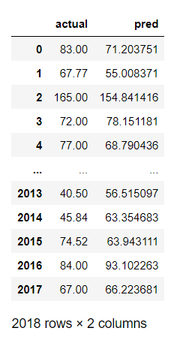

* **Dumping Model:**

import pickle

pickle.dump(pipe, open('BangloreHousePricePredictioModel.pkl', 'wb'))

pipe.predict(pd.DataFrame([['1st Phase JP Nagar', '2', '1000', '2']], columns=['location', 'size_BHK', 'total_sqft', 'bathroom']))

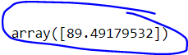

pipe.predict(pd.DataFrame([['Indira Nagar', '2', '1000', '2']], columns=['location', 'size_BHK', 'total_sqft', 'bathroom']))



* **Backend:**
* **Description:** In this module we had connected our trained model with this Django website.

from django.shortcuts import render

import pandas as pd

import pickle

def predict_price_actual(request):

model = pickle.load(open('BangloreHousePricePredictioModel.pkl', 'rb'))

location = request.GET['location']

sqft = request.GET['sqft']

bath = request.GET['bath']

bhk = request.GET['bhk']

print(location, "\n")

print(sqft, "\n")

print(bath, "\n")

print(bhk, "\n")

prediction = model.predict(pd.DataFrame([[location, bhk, sqft, bath]], columns=["location", "size_BHK", "total_sqft", "bathroom"]))

print(prediction, "rupees")

return render(request, "result.html", {'ans': prediction[0]})

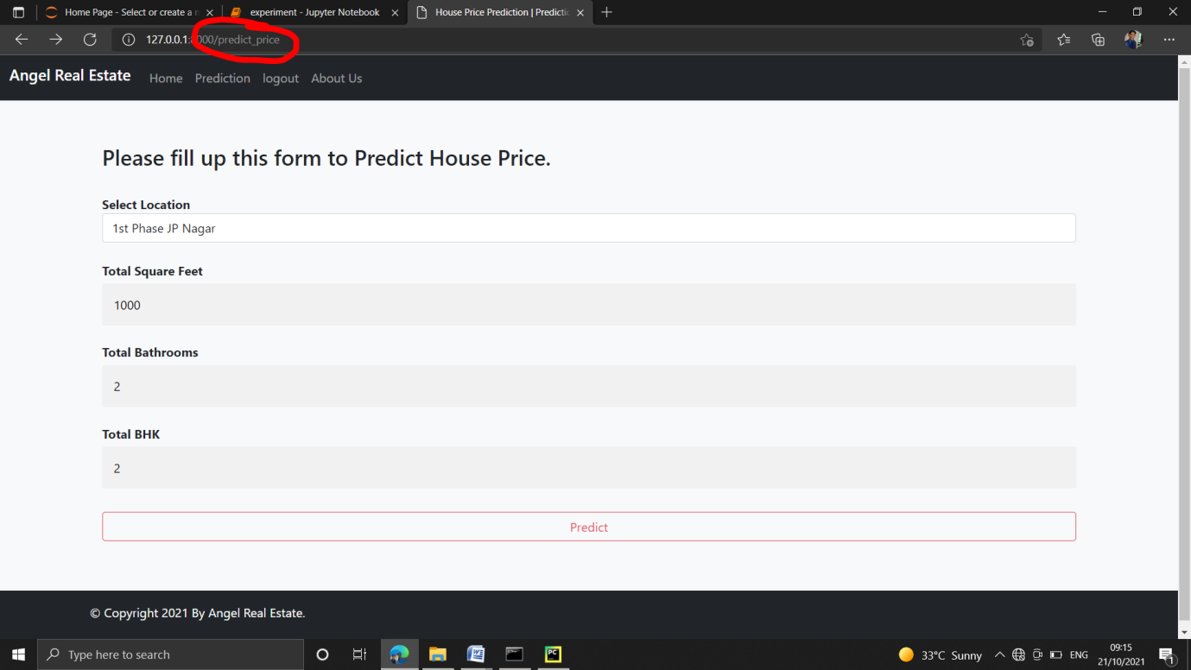

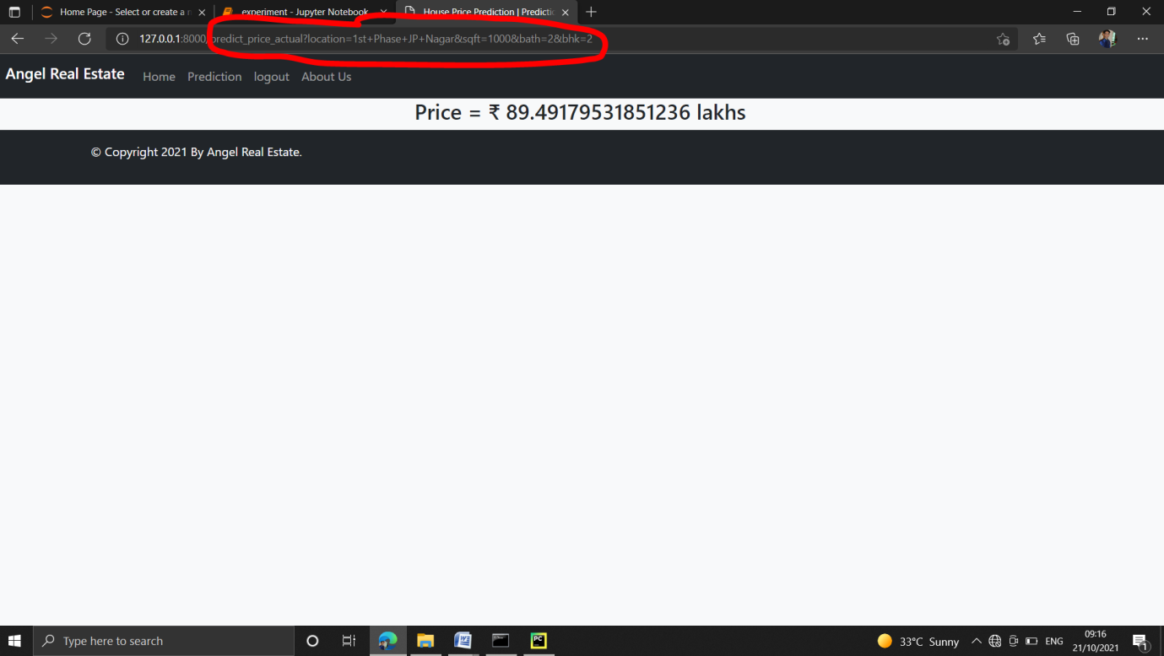

**3 – Ending Note:**

Here we conclude our project-I. We had completed all our work remaining from last report. Please give your valuable suggestions so we can now work on it and can complete it in permit able time.

**4 - Conclusion:**

As part of second mid presentation we have completed our SRS and other three progress report and also, we are done with around 80% - 90% work on actual system implementation. If some changes are required then we will take that into consideration and do changes in completed work.

\*\*\*\*\**The End*\*\*\*\*\*